IT & Networking

This document will cover the integration of a Sereact system into a warehouse networking environment.  
The Sereact Robotic Piece Picking System is a powerful and versatile automation solution that leverages cutting-edge technology to optimize warehouse and distribution center operations. At the heart of the system is a Linux computer with dedicated compute hardware, which runs the core software and additional middleware that integrates the system into the warehouse. The diagram depicts the full system.

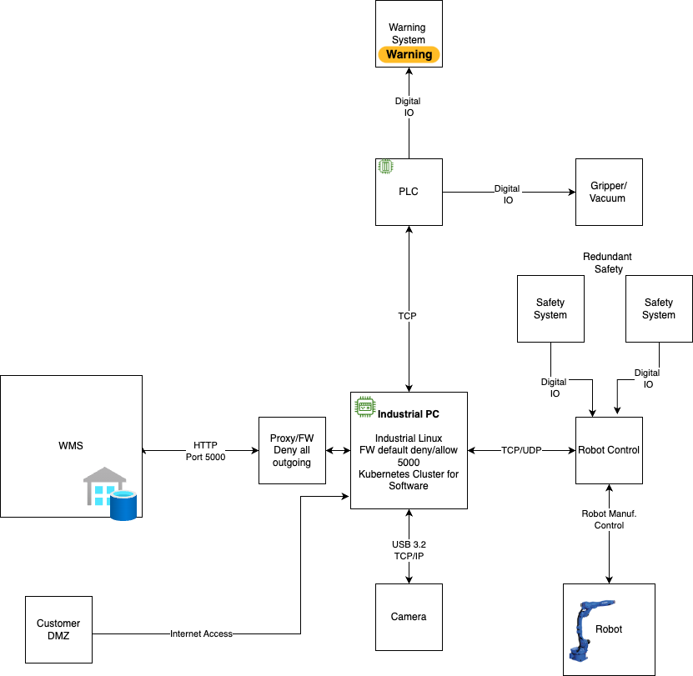

The core software is housed within a Docker container, which spawns multiple processes for controlling the robot, cameras, AI model inference, and ensures the health of these processes and connections. This software is also responsible for handling gripper communication and connecting to I/O and PLC devices to manage all necessary tasks.

One of the key benefits of the Sereact system is its flexibility and ease of use. The core software can be accessed and controlled via a web browser on an HMI, or through API calls, making it simple to integrate into existing warehouse management systems.

To further enhance its capabilities, the Sereact system also features a Kubernetes cluster for any necessary middleware and communication layers. This ensures that the system is scalable, reliable, and able to handle even the most complex logistics operations with ease.

IT Infrastructure



## Security

The Sereact Robotic Piece Picking System has been carefully designed to ensure the highest level of security and data privacy. The system is configured to allow only minimal and necessary information flow between the warehouse's internal IT network and the host PC running the piece picking application.

To further enhance security, the Sereact system is capable of running fully offline without any internet access, eliminating the risk of external cyber threats. Additionally, each system is equipped with an external firewall that is integrated to allow only the absolute minimal and necessary communication.

To provide an additional layer of protection, the internal Linux firewall is configured in the same way, creating a double fail-safe mechanism. This ensures that the system is fully secured and that all data is protected, making the Sereact system a reliable and trustworthy choice for warehouse and distribution center operations.

## WMS Communication

The system is designed to seamlessly integrate with a customer's existing warehouse management system (WMS) through a middleware layer. This layer connects the customer's proprietary WMS with our piece picking robots, ensuring smooth and efficient communication between the two systems.

The middleware application is hosted inside a Kubernetes Cluster on the Sereact computer, providing a reliable and scalable solution for managing high-volume order fulfillment and inventory management tasks. We are pleased to offer this application to our customers, as we have fully streamlined the process to ensure optimal performance.

Based on the customer's specific needs, the middleware application can request bins or new orders from the WMS, or it can run automatically when new orders come in. The application is also responsible for transferring input and output data into the WMS data format, ensuring that all information is accurately and consistently formatted.

## Remote support & Internet connectivity

Remote support channels require internet connectivity. This is usually implemented via giving the system access through a DMZ (Demilitarized Zone). The linux computer will get internet access on port 443. This can be further restricted to a few domains. Optionally, via AnyDesk or Teamviewer.  
  
   
- login.tailscale.com:443 -> remote access  
- api.sereact.ai 443 -> uploading and downloading new AI models and files  
- europe-west3-docker.pkg.dev:443 -> downloading updates and new versions

PLC Communication

Our system is enhanced with integrated PLCs (Programmable Logic Controllers), enabling it to communicate effectively not just with essential gripper hardware but also with existing warehouse infrastructure, such as conveyors and ports. This integrated communication capability ensures a seamless and efficient operation within the warehouse environment, facilitating a harmonious interaction between diverse hardware components.



In our ongoing projects, we employ a diverse array of communication protocols to ensure seamless interaction with existing hardware. These include:

* ProfiNet
* Modbus
* OPCUA
* TCP/IP
* Digital IO

While JSON is our serialization format of choice for its simplicity and efficiency, we maintain a flexible stance. We are open to exploring alternative serialization formats and communication protocols to best meet the needs of our projects and enhance our systems' interoperability and performance.